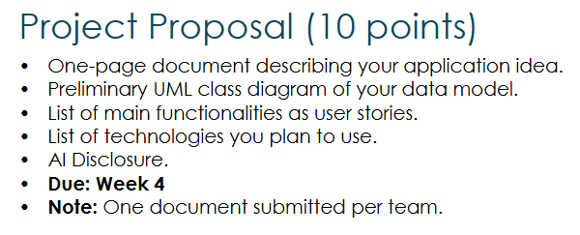
Clayton Brandt, Nathan McMichael, Toan Nguyen
Professor Roach
CSCI 3110-001
Due Date 17 September 2026
Packet Sniffers Project Proposal
Application Idea
Our website is called Earbud Explorer. It’ll help users find earbuds based on what they want. Users can filter earbuds by price, brand, battery life, noise cancellation, transparency mode, water resistance, Bluetooth version, and rating. The website will show earbuds that match the user's specifications.
Users can make an account, save earbuds to their favorites, save searches, and compare multiple earbuds. Users will also be able to view detailed information about each earbud. Admins will be able to add, edit, and delete earbuds, brands, and features. The website will use a database to store all of the earbud information.
The website will use JavaScript and AJAX so that filters and other features can update without having to reload the page. A REST API will be used to get and manage earbud information. Earbuds can have multiple features, and each feature can belong to multiple earbuds. This creates the many-to-many relationship required for the project.

User Stories
As a user I want to make an account and log in so I can save my earbuds and searches.
As a user I want to filter earbuds by price, brand, battery life, and other specifications so I can find earbuds that fit what I want.
As a user I want the results to update without refreshing the page so I can change my filters quickly.
As a user I want to view the details of an earbud so I can see all of its specifications.
As a user I want to compare multiple earbuds so I can see their differences.
As a user I want to save earbuds to my favorites so I can find them again later.
As a user I want to save my searches so I can use the same specifications again.
As an admin I want to add, edit, and delete earbuds so the database stays updated.
As an admin I want to add, edit, and delete brands and features so the earbuds can be organized correctly.
As a user I want to search and sort earbuds so I can find the ones I am looking for.

Technology We’ll Use
ASP.NET Core MVC / C# – main application and server-side logic.
Entity Framework Core / SQL Server – database access and storage.
RESTful Web API – retrieve and manage earbud data using GET, POST, PUT, and DELETE.
HTML/CSS / Bootstrap – responsive and customized user interface.
JavaScript / AJAX / Fetch API – asynchronous filtering and favorites without page reloads.
ASP.NET Core Identity – user authentication and admin authorization.
Git / GitHub Desktop – version control and team collaboration.

AI Disclosure
Our team used ChatGPT to review our proposal against the project requirements and improve the organization and clarity of our ideas. It helped us better understand how to structure our data model, including the many-to-many relationship between earbuds and features, and how our planned functionality connects to the project requirements. Our team will review, understand, and be responsible for all final design and implementation decisions.

